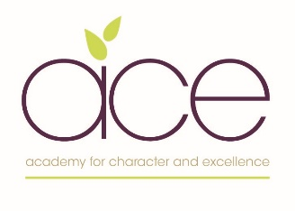
ACE WHOLE SCHOOL ORACY PROGRESSION DOCUMENT
This document has been written by headteachers and our ACE English leads. Oracy is at the heart of our curriculum and is key to ensuring all our pupils fully develop their character values and their ability to reflect on themselves as learners as they also continue to develop their ability to acquire new knowledge and skills in all subjects . We strongly believe that all pupils can only make good progress through the development of effective listening and speaking skills across all aspects of our curriculum.
We believe it is essential that all our children learn to express themselves clearly through spoken language. This helps them become effective learners and gain the ability to express themselves confidently, accurately and respectfully- giving all children a voice. We use our character gateways to ensure all children are given a wide range of opportunities to expand their vocabularies, develop viewpoints, justify their thinking and engage in opportunities to debate, reason, justify and collaborate. ,
 | 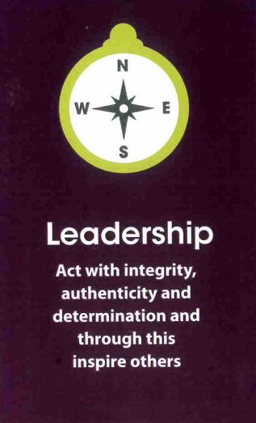 | 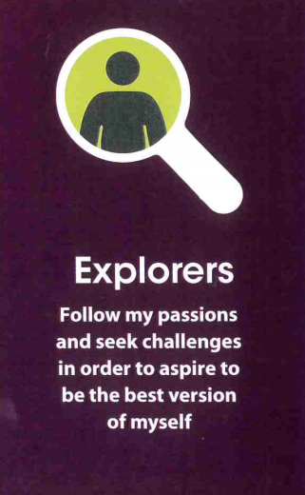 | 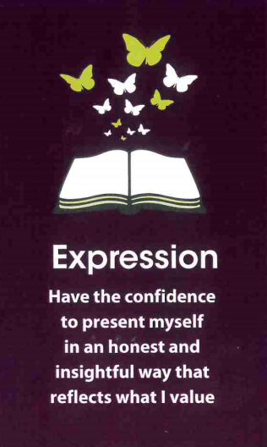 | 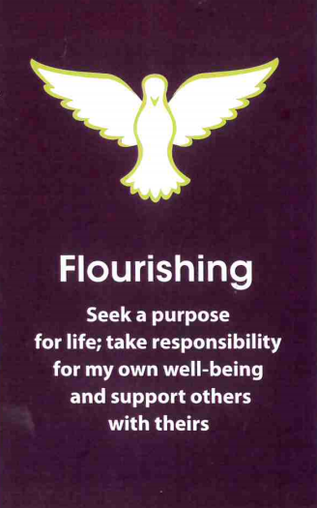
How we use the gateways to ensure opportunities to develop oracy skills for all
- Presenting a presentation that affects my community  - Presenting a campaign to make a difference  - Showing empathy by listening well and disagreeing respectfully  - Understanding the impact of my views, my talk on others and adapting my talk for others | - Inspire others through my talk and though my persuasive powers  - Lead a discussion or debate, knowing when to delegate to others  - Be able to stick to my viewpoint and opinions even when others disagree  - Know when to change my views having listened to my team | - Express my passions and interests with enthusiasm and clarity  - Rise to a challenge when presenting to an audience  - Continually improve my ability to listen well and converse well with others | - Increasingly develop confidence in my talk  - Express my values and justify them to others  - Take part in opportunities with an increasingly wider audience  - Endeavour to respond with honesty when I talk | - Support others as they speak and listen by using my body language, appreciative phrases and encouragement  - Take responsibility for rehearsing and planning my talk  - Take part in a range of opportunities to express myself so I can flourish

EYFS  ACE Oracy Progression 2023-24 | Year 1 | Year 2 |  | Year 3 | Year 4 | Year 5 | Year 6
How we talk: Gesture, tone and use of voice
Speak clearly with appropriate volume  Look at who is talking and who you are talking to  Begin to use gestures to support delivery meaning e.g. pointing at parts of a plant they are discussing | Speak clearly and confidently in a range of contexts  Use appropriate tone of voice in the right context e.g. To project their voice to a large audience.  Continue to use gesture to support delivery e.g. pointing at parts of a plant they are discussing | Speak clearly  and confidently  with  appropriate  volume and  pace in a  range of  contexts  Gestures start to  become  increasingly  natural to  support speech  e.g. gesturing  towards  someone if  referencing  their idea  Use body  language to  show active  listening and  support  meaning when  speaking e.g.  nodding along,  facial  expressions | Deliberately  selects gestures  that support the  delivery of ideas  e.g. gesturing  towards  someone if  referencing their  ideas  Deliberately  varies tone of  voice in order to  convey  meaning e.g.  speaking  authoritatively  during an expert  talk  Consider position  and posture  when addressing |  | Deliberately  select movement  and gesture  when addressing  an audience  To use pauses for  effect in  presentational  talk e.g. when  telling an  anecdote or joke  Use the  appropriate tone  of voice in the  right context e.g.  speaking calmly  when resolving  an issue in the  playground | Deliberately  varies tone of  voice in order  to convey  meaning e.g.  speaking  authoritatively  during an  expert talk, or  speaking with  pathos when  telling a sad  part of a story  Project their  voice to a large  audience  Gestures  become  increasingly  natural  Consciously  adapt tone,  pace and  volume of  voice within a  single context. | Speak fluently in  front of an  audience.  Have a stage  Presence  Consciously  adapt, tone,  pace and  volume of voice

EYFS | Year 1 | Year 2 | Year 3 | Year 4 | Year 5 | Year 6
The words we use – vocabulary, sentence structure and language choice
Use talk in play  to practice new  vocabulary e.g.  lighter, heavier  Begin to speak  in sentences  joining phrases  with words such  as ‘if, because,  so, could, but’ | Speak in  sentences using  joining phrases  to link ideas  Using  vocabulary  appropriately  specific to the  topic in hand  e.g.  lighter/heavier  rather than  bigger and  smaller  Take  opportunities to  try out new  language, even  if it is not always  correctly used  Use sentence  stems to link to  other’s ideas in  group  discussion e.g. ‘I  agree with…  because...’  ‘linking to…’  Use  conjunctions to  organise and  sequence ideas  e.g. firstly,  secondly, finally | Speaking in  sentences using  joining phrases  to create  longer  sentences  Adapt how to  speak in  different  situations  according to  the audience  e.g. asking  questions of a  museum  curator or  having a  conversation  with a visitor to  the classroom  Use sentence  stems to signal  when they are  building or  challenging  others’ ideas in  group’ | Be able to use  specialist  language to  describe their  own and  others’ talk  Use specialist  vocabulary e.g.  speak like an  archaeologist  Make precise  language  choices e.g.  instead of  describing a  cake as ‘ice’  using  ‘delectable’ | Carefully  consider the  words and  phrasing they use  to express their  ideas and how  this supports the  purpose of the  talk e.g. to  persuade or to  entertain | Use an  increasingly  sophisticated  range of  sentence stems  with fluency  and accuracy  to cite  evidence and  ask probing  questions  Consider the  words and  phrases used to  express their  ideas and how  this supports the  purpose of talk | Use and innovate  an increasingly  sophisticated  range of  sentence stems  with fluency and  accuracy  Vary sentence  structures and  length for effect  when speaking  Be comfortable  using idioms and  expressions

EYFS | Year 1 | Year 2 | Year 3 | Year 4 | Year 5 | Year 6
Developing metacognition through talk
Use ‘because’  to develop their  ideas  Ask simple  questions  Describe events  in detail | Offer reasons  for their  opinions  Recognise  when they  haven’t  understood  something and  ask a question  Explain ideas  and events in  chronological  order | Ask questions to  find out more  about a subject  Build on others’  ideas in  discussions  Make  connections  between what  has been said  and their own  and others’  experiences | Offer opinions  that aren’t their  own e.g. speaking on behalf of their group or pair  Begin to reflect  on discussions  and their own  oracy skills and  identify areas of  strength and  areas to  improve  Reach shared  agreement in  discussions | Give supporting  evidence e.g.  citing a text  (using sentence  stems) a previous  example or a  historical event  Ask probing  Questions  Reflect on their  own oracy skills  and identify  areas of strength  and areas to  improve and  begin to set own  targets | Draw upon  knowledge of  the world to  support their  own point of  view and  explore  different  perspectives  To be able to  give supporting  evidence e.g.  citing a text, a  previous  example or a  historical event  Identify when a  discussion is  going off topic  and be able to  bring it back on  track with  support and  use of sentence  stems e.g. That  might be true,  however what  do you think  about …? | Construct a  detailed  argument or  complex  narrative  Spontaneously  respond to and  offer increasingly  complex  questions, citing  evidence where  appropriate  Reflect on their  own and others’  oracy skills and  identify how to  improve.

